Functional Design 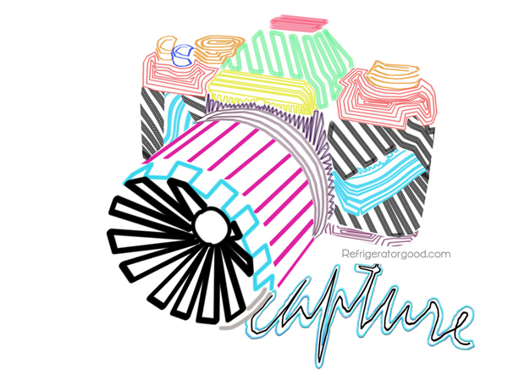
Lesson Objective:
Choose 3 objects that have a function or use. After choosing the objects think of one word per object that represents it’s function. VAGSE 1-1b. 3-1b,d

Example:

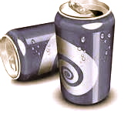
G
u
l
p

Computer Lab:
Choose 3 objects that have a function or use. Goggle the objects and search for images:
1. function word:
2. function word:
3. function word:
Using Microsoft word type out your function words and choose three fonts that visual work well with your object. Make sure that your font is at least set at 85-100

Example:
Gulp Gulp Gulp

Email me your images and fonts in a word document
jcyr@cpsed.net
