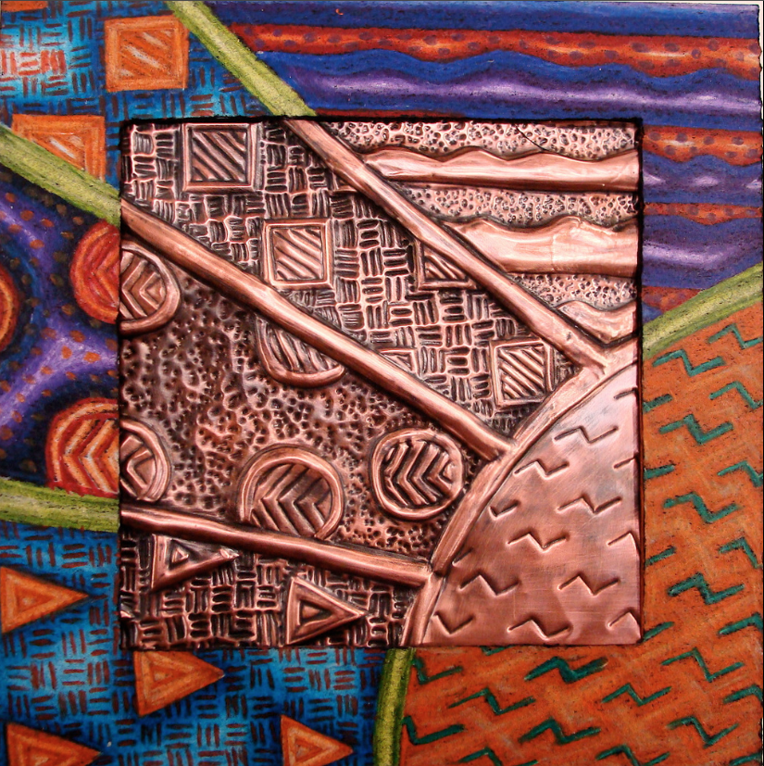 Copper Embossing
Embossing: to decorate a surface with a raised (relief) design.
Repousse: a French term meaning to “push up”.
Chasing: a term meaning to “push down”.

Lesson Objective: VAGSE 1-1b. 3-1b,d
- Choose 3 designs of the sun.
- Cut and paste them into a word document and email the doc to me.
- After choosing your image create a design that incorporates the following:
- BALANCE: radial OR asymmetrical
- LINE
- SHAPE
- TEXTURE
- PATTERN (design includes 5 patterns made up of line, shape & texture)
- COLOR THEORY

